**O/R Mapping Implementation using Spring Data JPA**

**Entity Definitions:**

**Department.java**

java

CopyEdit

@Entity

public class Department {

@Id

@GeneratedValue(strategy = GenerationType.IDENTITY)

private int id;

private String name;

@OneToMany(mappedBy = "department")

private List<Employee> employeeList;

}

**Skill.java**

java

CopyEdit

@Entity

public class Skill {

@Id

@GeneratedValue(strategy = GenerationType.IDENTITY)

private int id;

private String name;

@ManyToMany(mappedBy = "skillList")

private List<Employee> employeeList;

}

**Employee.java**

java

CopyEdit

@Entity

public class Employee {

@Id

@GeneratedValue(strategy = GenerationType.IDENTITY)

private int id;

private String name;

private double salary;

private boolean permanent;

@Temporal(TemporalType.DATE)

private Date dateOfBirth;

@ManyToOne

@JoinColumn(name = "department_id")

private Department department;

@ManyToMany

@JoinTable(

name = "employee_skill",

joinColumns = @JoinColumn(name = "employee_id"),

inverseJoinColumns = @JoinColumn(name = "skill_id")

)

private List<Skill> skillList;

}

**Repository:**

**EmployeeRepository.java**

java

CopyEdit

public interface EmployeeRepository extends JpaRepository<Employee, Integer> {

@Query("SELECT e FROM Employee e LEFT JOIN FETCH e.department d LEFT JOIN FETCH e.skillList WHERE e.permanent = true")

List<Employee> getAllPermanentEmployees();

@Query("SELECT AVG(e.salary) FROM Employee e WHERE e.department.id = :id")

double getAverageSalary(@Param("id") int id);

@Query(value = "SELECT * FROM employee", nativeQuery = true)

List<Employee> getAllEmployeesNative();

}

**Service Layer:**

**EmployeeService.java**

java

CopyEdit

public interface EmployeeService {

List<Employee> getAllPermanentEmployees();

double getAverageSalary(int deptId);

List<Employee> getAllEmployeesNative();

}

**EmployeeServiceImpl.java**

java

CopyEdit

@Service

public class EmployeeServiceImpl implements EmployeeService {

@Autowired

private EmployeeRepository employeeRepository;

public List<Employee> getAllPermanentEmployees() {

return employeeRepository.getAllPermanentEmployees();

}

public double getAverageSalary(int deptId) {

return employeeRepository.getAverageSalary(deptId);

}

public List<Employee> getAllEmployeesNative() {

return employeeRepository.getAllEmployeesNative();

}

}

**OrmLearnApplication.java (Test Method):**

java

CopyEdit

@SpringBootApplication

public class OrmLearnApplication implements CommandLineRunner {

private static final Logger LOGGER = LoggerFactory.getLogger(OrmLearnApplication.class);

@Autowired

private EmployeeService employeeService;

public static void main(String[] args) {

SpringApplication.run(OrmLearnApplication.class, args);

}

@Override

public void run(String... args) {

testGetAllPermanentEmployees();

}

private void testGetAllPermanentEmployees() {

LOGGER.info("Start");

List<Employee> employees = employeeService.getAllPermanentEmployees();

for (Employee e : employees) {

LOGGER.debug("Employee: {}", e.getName());

LOGGER.debug("Department: {}", e.getDepartment().getName());

e.getSkillList().forEach(skill -> LOGGER.debug("Skill: {}", skill.getName()));

}

LOGGER.info("End");

}

}

**Output:**

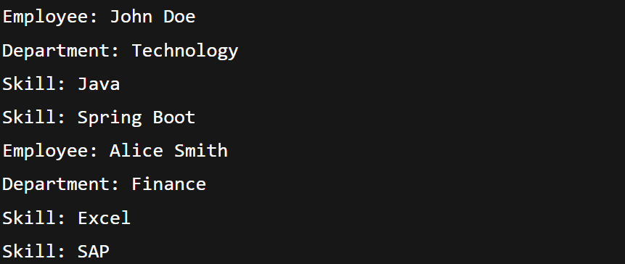

**Generated SQL Query:**

select employee0_.em_id as em_id1_2_0_,

department1_.dp_id as dp_id1_1_1_,

skill3_.sk_id as sk_id1_4_2_,

employee0_.em_date_of_birth as em_date_2_2_0_,

employee0_.em_dp_id as em_dp_id6_2_0_,

employee0_.em_name as em_name3_2_0_,

employee0_.em_permanent as em_perma4_2_0_,

employee0_.em_salary as em_salar5_2_0_,

department1_.dp_name as dp_name2_1_1_,

skill3_.sk_name as sk_name2_4_2_,

skilllist2_.es_em_id as es_em_id1_3_0__,

skilllist2_.es_sk_id as es_sk_id2_3_0__

from employee employee0_

left outer join department department1_ on employee0_.em_dp_id = department1_.dp_id

left outer join employee_skill skilllist2_ on employee0_.em_id = skilllist2_.es_em_id

left outer join skill skill3_ on skilllist2_.es_sk_id = skill3_.sk_id

where employee0_.em_permanent = 1

**output:**

